KAMYAB JAWAN PROGRAMME PHYSICAL VERIFICATION PROCESS

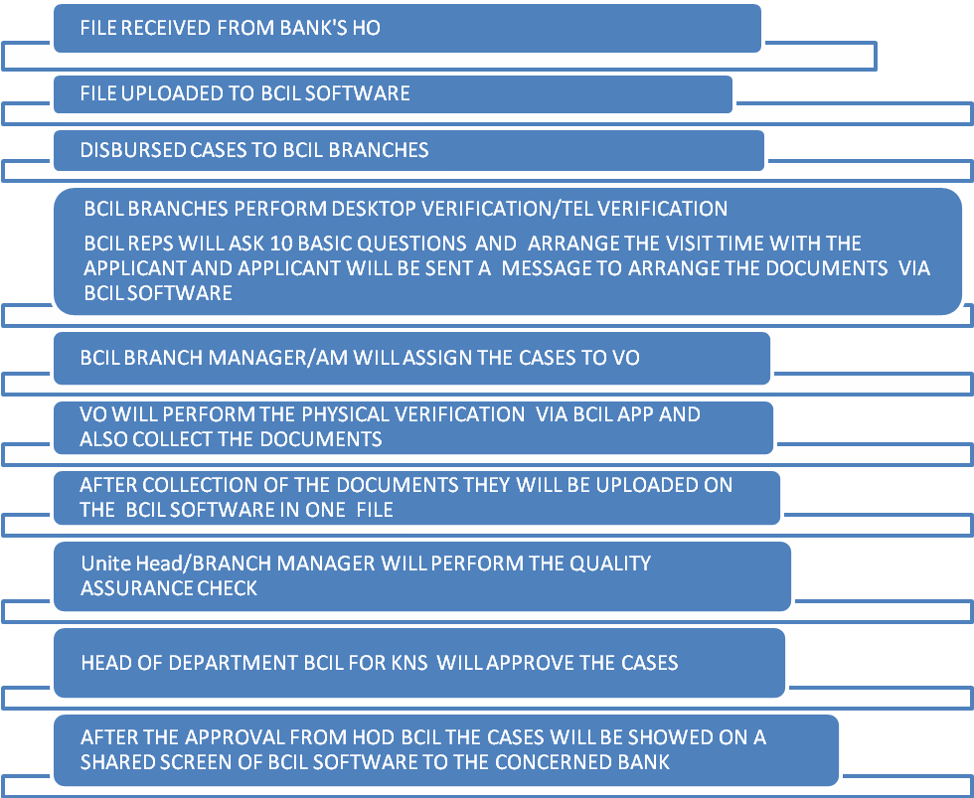

Main Menu Design
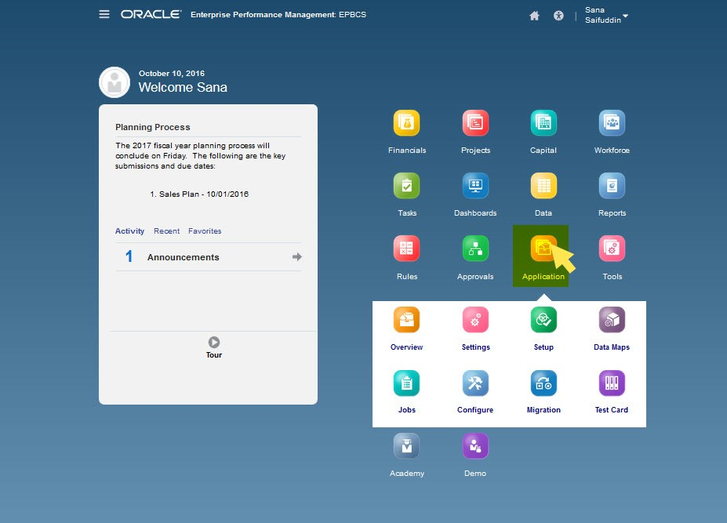
Please Design the Main Menu same as above mentioned Photo.

- I am sending you Excel file which is a guide for you to design the form and also database structure.
- Desktop verification contains basic ten questions which are highlighted in Excel file with Red color.
- The Uploading file system has to be designed for three banks.
- Dashboard PMKJ has to be designed for three banks with all filer. I will send you Dashboard Design.
- The Portal for Screen sharing has to be designed according our system.
- Integrate the SMS, Email and calling software with our System.
- BCIL, Region, Branches Setup and Bank Region, Branches etc.
- Documents uploading format like PDF, JPG, Img, PNG etc.
- Inquiry Form for all banks.
- Reports of Physical Verifications and other reports etc.
- GPRS location Map, Link and longitude and latitude convert into address like (Walton Road, Lahore Cantt.)
- Photos format also attached in our System. Residence, Business, Vehicle etc.
- Design the BCIL APP according to ERP. Please design the side bar or push notification.
- Notification System design in our ERP

RESIDENCE PICTURES
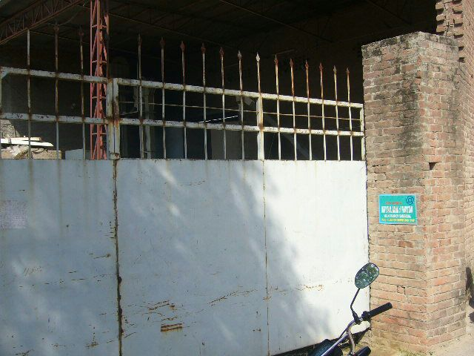 | 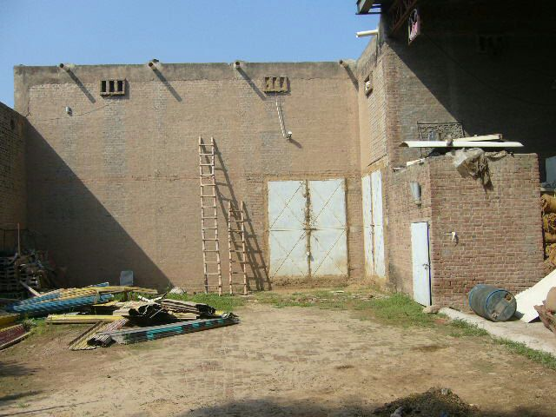
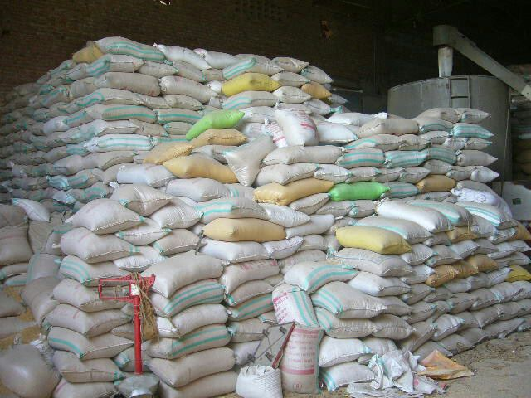 | 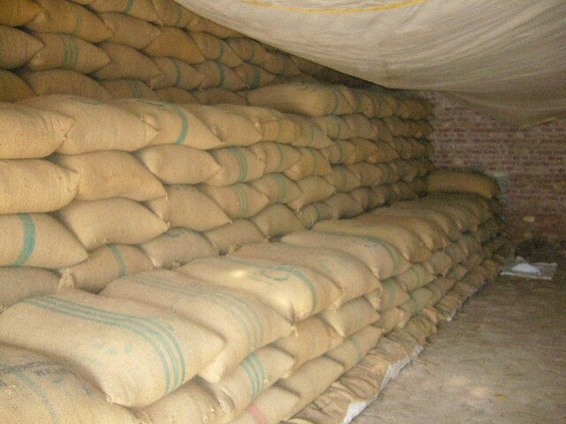

BUSINESS Pictures

GPRS LOCATION MAP
